# Task

* 1. Create all required fact table objects on BL_DM Layer (FCT_...).
* Grant all required privileges to BL_CL (Cleansing Layer).
* Create packages to load fact data (one package = one fact table) on BL_CL.
* Prepare document with description of your load and screenshot of data in the Fact Table.
* Test Procedure for Repeatable execution (it should produce same consistent results each time on a same source data).

# Solution

## DDL fact table

Фактовая таблица была создана на уровне BL_CM (скрипт в папке).

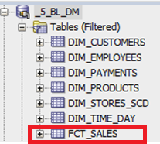

Результат выполнения:

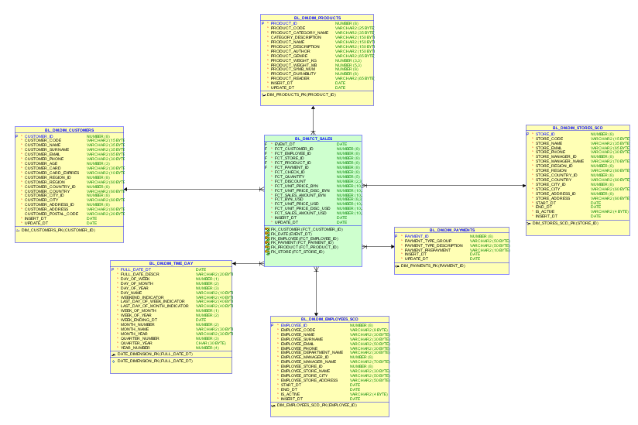

## Гранты

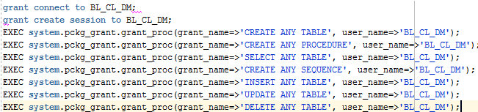

## Пакеты

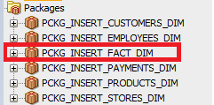

## Data load

